**CASE STUDY 1:**

Cooler System

* **The Cooler System is a form of embedded system that takes real time input of Temperature and makes decision whether the Cooler system needs to be turned ON/OFF.**
* **Block Diagram**:

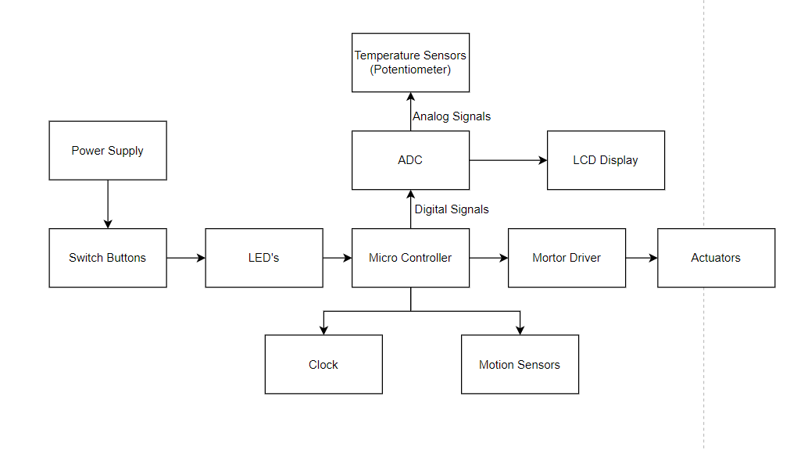

* ***Component Description***

**Power Supply:**

* External source of power supply that powers all devices, switches and microcontroller

**Switch Buttons:**

* Act as a circuit breaker to either power the system or isolate the system

**LED’s:**

* Act as a mean to communication with the user

**Microcontroller:**

* Performs all operations required by our system. Takes input as Temperature of the room and further processes this data to decide whether AC Needs to be turned on/off

**Motion Sensors:**

* To determine any human presence in the Room

**Temperature Sensors:**

* To determine the temperature of the room.

**ADC:**

* Converts the Analog signal from Potentiometer to Digital

**Motor Driver:**

* Used to drive the Actuator

**Actuators:**

* Externally connected devices that perform operation as per the decision which the microcontroller takes. (In my case, Turn ON/Off the Cooler)

**LCD Display:**

* To show Temperature readings

**Clock:**

* For Synchronization

**Concept of Operation:**

* Cooler System takes real time input of temperature from the surroundings and makes decision whether the AC needs to be ON/OFF

**Low Level Requirements:**

* Switches to turn ON/OFF the system
* Power Supply to the Microcontroller, Sensors and Actuators

**High Level Requirements:**

* To detect the Temperature of the room using temperature sensors
* To detect if people are present in the room
* To make decisions whether to turn ON/OFF the cooler